**Project Title: Time-Series Dataset: Evaluating the Socio-Ecological Performance of Organic Farming Systems in Bangladesh.**

**Name: Anika Tabbasum**

This study will review the performance of organic farming systems against socio-ecological indicators, with a particular focus on their contributions toward sustainable agriculture and rural development in Bangladesh. It is intended to assess the impacts of organic farming on biodiversity, soil fertility, and water conservation, with an emphasis on mitigation to climate change, while its socioeconomic benefits related to livelihood improvement, income stability, and community resilience are also considered.  We get the data from Bangladesh Agricultural Research Institute (BARI)Department of Agricultural Extension (DAE), Organic Farmers Association of Bangladesh (OFA), Food and Agriculture Organization (FAO).

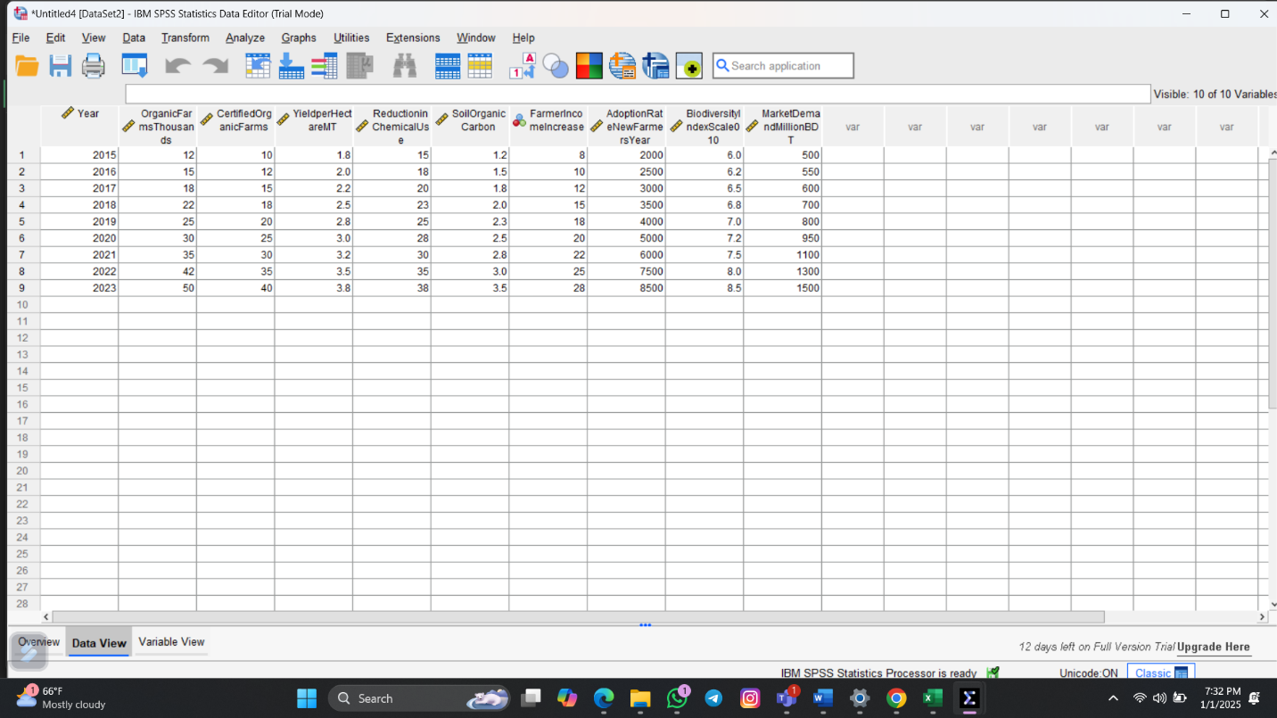

Between 2015 and 2023, the number of organic farms increased from 12,000 to 50,000. The percentage of chemical usage within 2023 stands at 38%. The income of organic farms increased by 28% in 2023. Between 2015 to 2023 biodiversity has increased from 6 to 8.5 in areas where organic farming is done.  Organic farming in Bangladesh enhances environmental services like soil health and biodiversity, apart from supporting rural livelihoods.